**Social Resilience :**

Resilience refers to the ability to bounce back or recover from difficult or challenging situations, setbacks, or adversity. It is the capacity to adapt and cope with stress, change, and trauma and to maintain a sense of balance and well-being in the face of adversity.

Social resilience refers to the ability of individuals, communities, and societies to withstand and recover from social or political disruptions, conflicts, or crises. It involves the capacity to maintain social cohesion, adapt to change, and address the root causes of social problems.

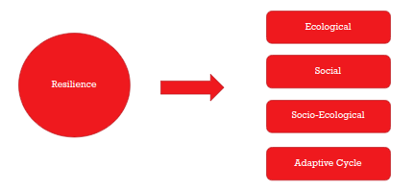

**Ecological Resilience:**

**…ability of these systems to absorb changes of state variables, driving variables, and parameters, and still persist”. ​ -C.S Hollins**

**Hollins**

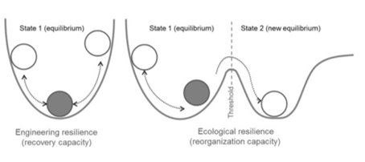

**Social Resilience:**

**The three capacities of social resilience include: coping capacities, adaptive capacities and transformative capacities (Keck and Sakdapolrak 2013). Coping capacities are the absorptive abilities of people to overcome immediate threats by using existing resources directly available to them. Adaptive capacities are the preventive mechanisms where people learn from the past and prepare for the future to adjust livelihood options accordingly. Transformative capacities reflect people’s ability to mobilise access to resources and assistance from the wider socio-political support system—the state and the civil society.**

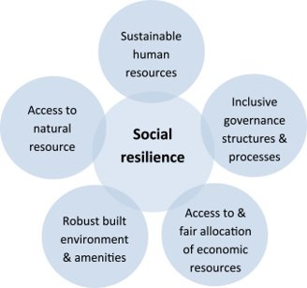

**Socio-Ecological and Adaptive Cycle of Resilience​**

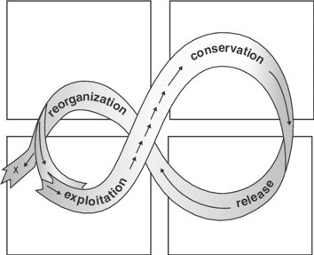

**Hollins & Gunderson**

The Sundarbans is a unique region located in the delta of the Ganges, Brahmaputra, and Meghna rivers, spanning across India and Bangladesh. The Sundarbans is a crucial ecosystem that provides a livelihood to millions of people and serves as a natural buffer against cyclones and other natural disasters. However, the Sundarbans is also one of the most vulnerable regions in the world to climate change and environmental degradation, which threaten the social and economic well-being of the local communities. Social resilience is the ability of communities to cope with and adapt to changing circumstances, such as natural disasters, economic downturns, and social upheavals. In the context of the Sundarbans, social resilience is crucial to ensure the survival and well-being of the local communities in the face of environmental and economic challenges. There are several factors that contribute to social resilience in the Sundarbans. One of the most important is the strong social networks and community bonds that exist in the region. The people of the Sundarbans have a long tradition of working together and supporting each other in times of need, which has helped them to cope with the frequent cyclones, floods, and other natural disasters that occur in the region. Another factor that contributes to social resilience in the Sundarbans is the diversity of livelihoods and income sources. The people of the Sundarbans rely on a range of activities such as fishing, farming, honey collection, and ecotourism, which provide them with multiple sources of income and reduce their dependence on any one activity. Finally, the role of local institutions and governance structures is crucial in building social resilience in the Sundarbans. Strong local institutions, such as community-based organisations and local government bodies, can help to mobilise resources, provide support to vulnerable groups, and facilitate communication and coordination among different stakeholders. Overall, social resilience in the Sundarbans is a complex and multifaceted concept that requires a holistic approach to address the challenges faced by the local communities. By strengthening social networks, diversifying livelihoods, and promoting effective local governance, it is possible to build resilience in the Sundarbans and ensure the well-being of the people who live there.

CLOC K2A SSG

SWOT

**Kumirmari, Gosaba**

1. Biodiversity: The Sundarbans is a highly biodiverse ecosystem that is home to a variety of plant and animal species. This biodiversity helps to ensure the resilience of the ecosystem by providing multiple options for adaptation and recovery.
2. Mangrove Forests: The Sundarbans is primarily composed of mangrove forests, which are highly adapted to the region's saline and waterlogged conditions. These forests provide important ecosystem services, such as stabilizing shorelines, filtering pollutants, and providing habitat for wildlife.
3. Traditional Knowledge: The indigenous communities living in the Sundarbans have developed a deep understanding of the local environment and have adapted their practices accordingly. This traditional knowledge helps to ensure the resilience of the ecosystem by providing guidance on sustainable resource management and disaster preparedness.
4. Adaptive Capacity: The Sundarbans is a dynamic and ever-changing ecosystem, and its inhabitants have developed the ability to adapt to changing conditions. This adaptive capacity is critical for ensuring the resilience of the ecosystem in the face of natural and human-induced disturbances.
5. Institutional Support: The government of Bangladesh has established several institutions to support the conservation and sustainable use of the Sundarbans. These institutions, such as the Sundarbans Management Committee, provide support for research, monitoring, and management activities, which are essential for maintaining the resilience of the ecosystem.

